**7.1 operating system**

**Name_____________ class____________**

**1.**

An operating system (OS) is usually pre-installed on a new computer.

The OS performs a number of different tasks such as memory management and security management.

**(i)** State **three** memory management tasks the OS performs.

1 ....................................................................................................................................

.......................................................................................................................................

2 ...........................................................................................................................................................................................................................................................................

3 ....................................................................................................................................

.......................................................................................................................................

[3]

**(ii)** State **three** security management tasks the OS performs.

1 ....................................................................................................................................

....................................................................................................................................... 2 ....................................................................................................................................

.......................................................................................................................................

3 ....................................................................................................................................

.......................................................................................................................................

[3]

**(iii)** State **two** tasks, other than memory management and security management that are carried out by an OS.

1 ....................................................................................................................................

.......................................................................................................................................

2 ....................................................................................................................................

.......................................................................................................................................

[2]

**2.**

An operating system (OS) is usually pre-installed on a new computer.

The OS performs a number of different tasks such as file management and peripheral management.

**(i)** State **three** file management tasks the OS performs.

1 ....................................................................................................................................

......................................................................................................................................

2 ....................................................................................................................................

.......................................................................................................................................

3 ....................................................................................................................................

.......................................................................................................................................

[3]

**(ii)** State **three** printer management tasks the OS performs.

1 ...........................................................................................................................................................................................................................................................................

2 ...........................................................................................................................................................................................................................................................................

3 ....................................................................................................................................

.......................................................................................................................................

[3]

**3.**

**(a)** The operating system (OS) contains code for performing various management tasks.

The appropriate code is run when the user performs various actions.

Draw a line to link each OS management task to the appropriate user action.

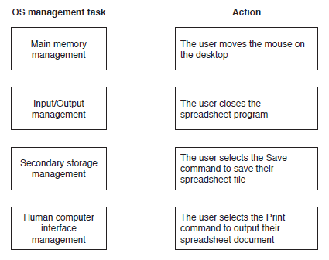

[3]